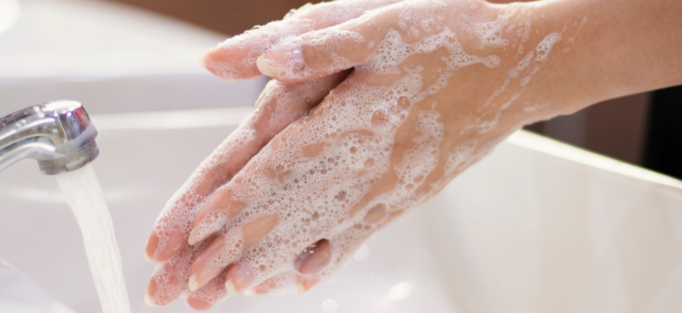
ANY APPLICANT, VISITOR, OR RETURNING EMPLOYEE

EMPLOYEES – if you answer yes to any of the following questions, please contact Health Services immediately.
- Have you been to a COVID-19 affected area (China, Italy, Iran, Japan, Singapore, South Korea or any other location that has active community transmission) within the last 14 days?
- Have you had contact with a confirmed case or a person under investigation for COVID-19?
- Do you currently have fever, chills, cough, sore throat or shortness of
breath?
APPLICANTS & VISITORS – if you answered no, then you are fine to enter. If you answered yes to any of the above questions, please do not enter. Contact the person you are supposed to meet and reschedule for another time after 14 days. Applicants call 403-652-8404

Thank you for your cooperation.

