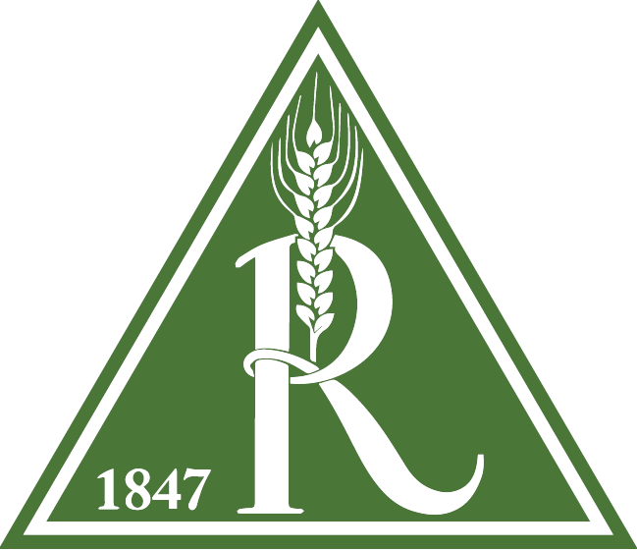

ATTENTION CONTRACTORS, DRIVERS, and other NON RAHR MALTING EMPLOYEES

Rahr Corporation, is paying close attention to the Coronavirus outbreak (COVID-19).

In an effort to protect the health and safety of our staff, and yourselves, we ask that you do not enter any of the facility, without explicit permission.

Contact Cody Marshall at 403-747-4238 to get permission
If you are showing any of the following symptoms, please leave the site immediately:
- Fever
- Cough
- Other Respiratory Issues like trouble breathing

For those with explicit permission, please follow normal sanitation protocols:

- Wash hands for a minimum of 20 seconds
- Avoid touching eyes, nose, or mouth
- Avoid contact with people that are sick
- When coughing or sneezing cover your mouth by coughing into your arm or tissue

If you have any questions you can contact Cody at 403-747-4238
Thank you for your understanding,
Rahr Malting Canada Ltd.

